EXAMPLE

8

9

7

2

4

5

8

6

YOUR NAME: __________________________________
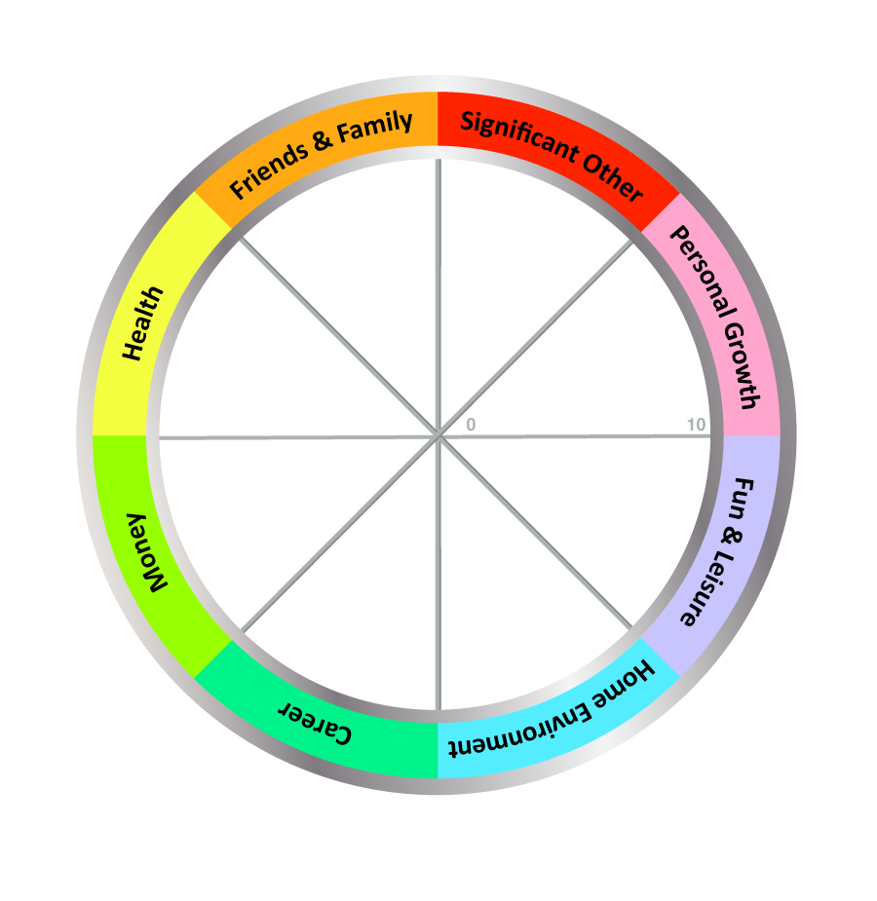

TODAY'S DATE: ____________________

COMPLETE THE WHEEL:

1. Review the 8 Wheel Categories - think briefly what a satisfying life might look like for you in each area.

2. Next, draw a line across each segment that represents your satisfaction score for each area.

- Imagine the centre of the wheel is 0 and the outer edge is 10
- Choose a value between 1 (very dissatisfied) and 10 (fully satisfied)
- Now draw a line and write the score alongside (see example above)

IMPORTANT: Use the FIRST number (score) that pops into your head, not the number you think it should be!

The Wheel of Life Exercise – Instructions for the Coach

Notes:
- Balance is personal and unique to each individual - what may be satisfying or balanced for some may be stressful or boring for others.
- This exercise raises a client's awareness and allows the client to plan a life that is more satisfying and closer to their definition of balance. It also helps clarify priorities for goal-setting.
- Balance must be assessed over time. A regular check-in (eg. with this exercise) can highlight useful patterns and help your clients learn even more about themselves. You can do this with them, or recommend they do it for themselves.
- Another option is for your client to ask someone who knows them well to complete the scores for them (sometimes it's helpful to see an outside perception of your life 'balance'). Important: This must be someone they trust and whose opinion they value - and remember that others may have hidden agendas.

Detailed Instructions:
- Ask your client to review the 8 categories on their Wheel of Life. The categories should together create a view of a balanced life for them. If necessary they can split category segments to add in something that is missing, or re-label an area to make it more meaningful for them. Examples of changes are:
  - Family and Friends: Split "Family and Friends" into separate categories.
  - Significant Other: Changing the category name to "Dating", "Relationship" or "Life Partner".
  - Career: Changing the category name to "Motherhood", "Work", "Business" or "Volunteering".
  - Finances: Changing the category name to "Money", "Financial Security" or "Financial Wellbeing".
  - Health: The category name could be split or changed to "Emotional", "Physical", "Fitness", "Spiritual" or "Wellbeing".
  - Home Environment: The category could split or change to "Work Environment" for career or business clients.
  - Fun & Leisure: The category name could change to "Recreation"
  - Personal Growth: The category name could change to "Learning", "Self-Development" or "Spiritual"
  - Other categories to add could include "Security", "Service", "Leadership", "Achievement" or "Community".
- Ask your client to think about what success or satisfaction would feel like for each area.
- Now ask them to rank their level of satisfaction with each area of their life by drawing a line across each segment. Ask them to place a value between 1 (very dissatisfied) and 10 (fully satisfied) against each area to show how satisfied they are currently with each category in their life.
- The new perimeter of the circle represents their Wheel of Life. You can ask your client, "Is it a bumpy ride?"
- Now, looking at the wheel here are some great questions to ask your client to take the exercise deeper:
  - Are there any surprises for you?
  - How do you feel about your life as you look at your Wheel?
  - How do you currently spend time in these areas? How would you like to spend time in these areas?
  - What would make that a score of 10?
  - What would a score of 10 look like?
  - Which of these categories would you most like to improve?
  - How could you make space for these changes in your life?
  - What help and support might you need from others to make changes and be more satisfied with your life?
  - What change should you make first? And what change do you want to make first?
  - If there was one key action you could take that would begin to bring everything into balance, what would it be?
- Taking action--the final step. To wrap-up the exercise you can ask your client to identify one action for each area, and then pick 1-3 actions to get started. You could also ask them to choose the 3 areas they most want to work on and identify an action for each. TIP: If your client is extremely busy or stressed try asking, "What is the smallest step you could take to get started?"

